3D reconstruction from correspondences derived from perceived motion

Richard Kirby*, Ross Whitaker

University of Utah, School of Computing, 50 S. Central Campus Drive Room 3190, SLC UT, USA, 84112

**Abstract**. 3D reconstruction from image pairs taken from different camera perspectives relies on finding corresponding points between the images and using those corresponding points to estimate a dense disparity map. Today's correspondence finding algorithms primarily use image features or pixel intensities common between image pairs. Some 3D computer vision applications, however, don't produce the desired results using correspondences derived from image features or pixel intensities. Two examples are the multimodal camera rig and the center region of a coaxial camera rig. In this paper we present an image correspondence finding technique that aligns pairs of image sequences using optical flow fields. Our method applies to applications where there is inherent motion between the camera rig and the scene and where the scene has enough visual texture to produce optical flow. We apply the technique to a traditional binocular stereo rig consisting of an RGB/IR camera pair and to a coaxial camera rig. We present results for synthetic flow fields and for real images sequences. With real image sequences we achieve flow field alignment of better than 1/10 of a pixel and reconstruction of relative camera/scene velocity of ??.

**Keywords**: image correspondence finding, 3D reconstruction, stereo endoscope, stereo borescope, multi-modal, graph cuts.

**\***Richard Kirby**,** E-mail: [richard.kirby@utah.edu](mailto:myemail@university.edu)

# 1 Introduction

Finding corresponding points in image pairs taken from two different perspectives is one of the most active areas of research in computer vision [16, 32, 34]. It forms the basis of 3D reconstruction as well as being a critical component of many other computer vision and image processing applications that require pixel by pixel alignment between image pairs [15, 41].

Existing correspondence finding techniques are based on matching pixel intensity values or features which are derived from pixel intensity values. This, in turn, allows the estimation of dense disparity maps which, given the camera geometry, allows the estimation of dense depth maps. Where image registration is the ultimate goal, the correspondences provide the geometrical transformations that allows one image, the sensed image, to be transformed into the second image, the reference image.

There are computer vision applications, however, where traditional correspondence finding techniques do not produce the desired results. Two notably cases are multimodal camera rigs where the images produced from different sensor types are not similar enough to be aligned using pixel intensities or features [41] and the center region of a coaxial camera rig [28] where the disparity is too small to produce good triangulation. There are also multi-camera applications where it is desirable to augment the use of pixel intensities and/or image features to improve the finding of intra-camera correspondences.

In this paper we introduce a novel automated method for finding correspondences using the optical flow fields from two cameras. We apply the technique to images acquired by a multimodal stereo rig where one camera contains an RGB sensor and the other camera contains an IR sensor, as well as to a coaxial camera rig. In applications where there is sufficient motion between the camera rig and the scene (scanning security camera, camera mounted on a vehicle, endoscope, etc.) and where the scene exhibits enough texture to produce optical flow, our method finds correspondences between multi-view image sequences without using intra-camera pixel intensities or features. From these correspondences we estimate dense disparity maps with accuracies similar to, and in certain cases, substantially better than, techniques that align images based on image features or pixel intensities.

This paper extends the work previously presented in two conference publications [19, 20] that solved the energy minimization problem using variational methods. In this paper we apply a well known graph-cuts algorithm to solve the energy minimization problem, which produces notably better results, we add additional support to the derivations, and we test the method on a wider range of images.

# 2 Related Work

## 2.1 Multimodal Binocular Stereo

Aligning images from stereo rigs consisting of cameras with multimodal sensors has been an active research area for the last decade and a half. Initially inspired by the work done to match medical images to models [38] it has more recently been motivated by the need for surveillance systems that use a combination of visible light and infrared cameras to detect targets. As noted by Yaman and Kalkan [39], traditional image alignment techniques used in stereo vision are not applicable to multimodal camera rigs because the pixel intensities can be substantially different in a visible light image vs. an IR image. See Fig. 1 for an example of an IR/RGB image pair. Solutions to the multimodal problem fall into two broad categories. The first uses Mutual Information (MI). MI was original proposed by Viola and Wells [38] to match medical images to models. To our knowledge, Egnal [10] was the first to use MI as a similarity measure to match multimodal stereo images. Since then, numerous improvements have been made including adaptive windowing [11], incorporating prior probabilities [12], regions of interest [23-25], and extending MI using gradient information [8].

More recently, local self similarity (LSS), originally used in template matching, was proposed for use in a multimodal camera rig [35]. Most recently Yaman and Kalkan [39] used MI to generate dense disparity maps from multimodal camera rigs.

The method we present avoids using visual similarity measures between the images from the two different sensor types by computing the optical flow fields from the two sensors and then aligning the flow fields. This permits images with no common features to be aligned as long as there is motion between the camera and the scene and the scene has enough texture to produce optical flow.

Verri and Poggio [37] have shown that in many cases optical flow is not equivalent to the motion field. While optical flow algorithms have improved substantially since the Verri and Poggio paper (see [33] and [7] for summaries of the progression of optical flow algorithm development); optical flow errors caused by the aperture problem, non-Lambertian surfaces, and non-uniform changing illumination, still exist.

For finding image correspondences, however, the optical flow fields do not need to be equivalent to the motion fields. For example, errors caused by the aperture problem where only the motion tangential to edges is detected or errors caused by moving shadows, will be perceived by the two sensors identically and alignment is unaffected. The primary requirement is that the optical flow computation be invariant to different light wavelengths.

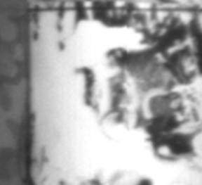 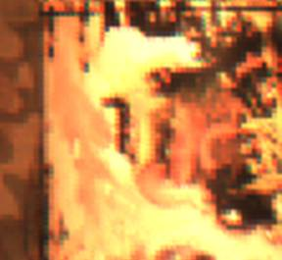

(a)

(b)

Fig. 1 Multimodal camera rig image pair: (a) IR and (b) RGB.

## 2.2 Depth from Zooming - Coaxial Camera

Depth from images taken at different focal lengths along a common optical axis was first proposed by Ma and Olsen [28]. Lavest et al. [27, 26] provide a proof for inferring 3D data from images taken at multiple focal lengths and models a revolving object. Asada et al. [1] and Baba et al. [2] present a method for doing 3D reconstruction using blur from zoom. Gao et al. [13] present a distance measurement system for mobile robots using zooming. Most recently, Zhang and Qi [40] describe a method for 3D reconstruction from multi-focal length images using a snake-search algorithm.

The primary reason researchers have focused on using a single camera at different focal lengths to do 3D reconstruction has been cost. However, there are several other advantages. Ma and Olsen alluded to the fact that a depth from zoom camera exhibits substantially smaller occlusions than an equivalent binocular stereo camera rig. Additionally, there are applications where a stereo baseline is prohibitive (endoscope or bore scope) and where the known correspondence point on the optical axis is an advantage to image registration. Finally, where image registration is the ultimate objective of the application (e.g. alignment of images from two different types of sensors without attempting 3D reconstruction), a coaxial camera produces substantially smaller disparity errors than a binocular stereo rig.

The coaxial camera rig [18] is equivalent to simultaneous depth from zooming, but instead of changing the focal length of a single fixed camera, two cameras are arranged such that the cameras form images along the same optical axis. This is done by splitting the optical path with a beam splitter and aligning the two cameras such that their optical centers image the same point in the 3D scene. The coaxial camera rig combined with image correspondences derived from perceived motion overcomes the two main problems of depth from zooming. First, simultaneous images taken at two different focal lengths overcomes the stationary scene constraint of depth from zooming. Second, using the flow field to align image pairs overcomes the unrecoverable point problem in the center region described by Ma and Olsen. This later advantage is due to the depth estimate being derived from the ratio of the flow fields taken at different focal lengths as opposed to the extremely small disparities found in the center region of a coaxial camera rig.

# 3 Energy Formulation

In this section, we derive energy functionals that relate the optical flow in one camera view to the optical flow in a second camera view. This type of functional can be solved using one of several energy minimization algorithm. We show derivations for a traditional binocular stereo camera rig and for a coaxial camera rig. However, the same methodology will work with any multi-view camera rig as long as the mathematical relationship between the optical flow in the two cameras can be derived.

## 3.1 Dual Focal Length Binocular Stereo Epipolar Geometry

Referring to Figure 2, let ${\overline{x}}_{l}≔{(x_{l},y_{l})}^{T}$, ${\overline{x}}_{r}≔{(x_{r},y_{r})}^{T}$ represent points in the image domain of the left and right cameras. Let $\overline{h}(\overline{x})≔$ the disparity between ${\overline{x}}_{l}$ and ${\overline{x}}_{r}$ such that ${\overline{x}}_{l}$ and ${\overline{x}}_{r}+\overline{h}(\overline{{\overline{x}}_{r}})$ represent the same point $\overline{X}\left({\overline{x}}_{l}\right)≔(X,Y)$ in the scene. Let $f_{l}$, $f_{r}≔$ the focal lengths of the left and right cameras respectively and $Z_{0}\left({\overline{x}}_{l}\right), Z_{1}({\overline{x}}_{l})≔$ the distance between the optical center of the left camera and a point in the scene corresponding to ${\overline{x}}_{l}$ at time $t=0$ and $t=1$, the distance being measured along the optical axis. $∆Z\left({\overline{x}}_{l}\right)$ is then the difference along the Z axis for each point between $t=0$ and $t=1$. $\overline{X}≔$ the distance from the optical axis to a point in the scene and $∆\overline{X}≔$ the change in the distance from the optical axis between time $t=0$ and $t=1$. $b≔$ the stereo baseline. ${\overline{w}}_{l}, {\overline{w}}_{r}≔$ the projection of the 3D motion (the ideal optical flow) of point in the scene onto the image planes in the left and right cameras.

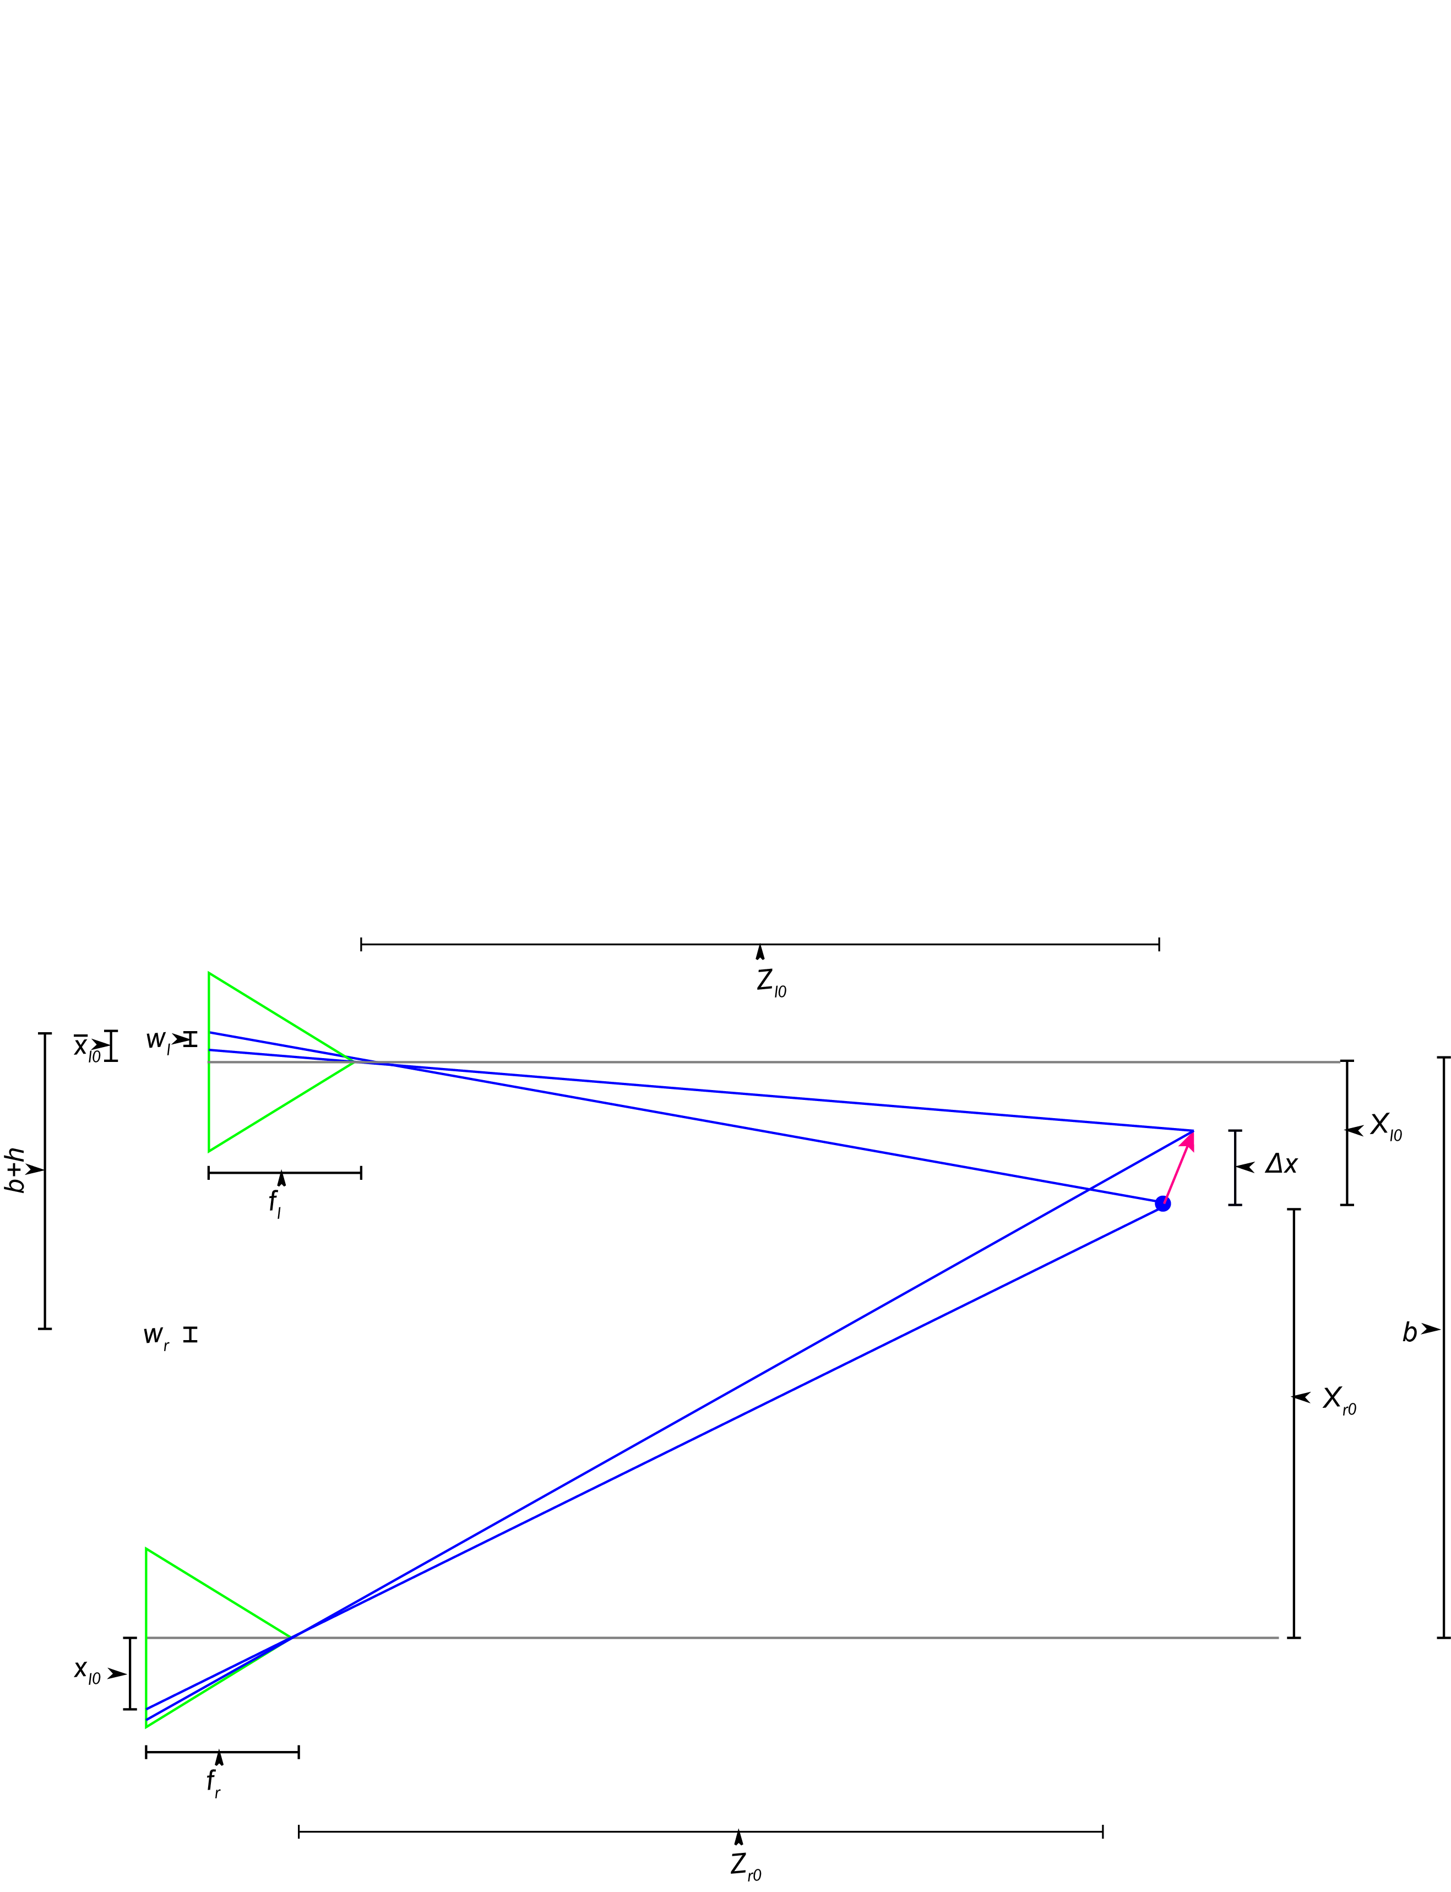

Fig. 2 Dual focal length binocular stereo camera rig geometry X-Z view.

First derive equations for $\overline{h}\left({\overline{x}}_{l}\right)=\left[\begin{matrix}h_{x}(x_{l}) \\ h_{y}(y_{l})\end{matrix}\right]$ which is the disparity in $x$ and $y$ with the left image being the reference image. Notice that disparity does not depend on $\frac{dZ}{dt}=\dot{Z}$. For the $x$ direction, we start with the projection equations for a pinhole camera.

$x_{l}=-\frac{f_{l}X_{l}}{Z_{l}}$ (1)

$x_{r}=-\frac{f_{r}X_{r}}{Z_{r}}$ (2)

where:

${{b=X}_{r}-X}_{l}$ (3)

solving for the disparity in the $x$ direction gives;

$x_{l}-x_{r}=h_{x}=\frac{f_{r}X_{r}}{Z_{r}}-\frac{f_{l}X_{l}}{Z_{l}}$ (4)

$h_{x}=\frac{\left(-\frac{f_{r}}{f_{l}}x_{l}Z_{l}\right)+f_{r}b+x_{l}Z_{l}-x_{l}d}{Z_{l}+d}$ (5)

If the focal lengths in the left and right cameras are equal (e.g. $d=0$ and $f_{l}=f_{r}$), equation (5) reduces to the well known binocular stereo disparity equation:

$h=\frac{fb}{Z}$ (6)

Referring to Fig. 3, we use the same method to derive the disparity in the y direction:

$h_{y}=\frac{y_{l}\left(Z_{l}+d-\frac{f_{r}}{f_{l}}Z_{l}\right)}{Z_{l}+d}$ (7)

This equation reduces to the equation for a traditional stereo epipolar line for $d=0$ and $f_{l}=f_{r}$:

$h_{y}\left(x_{f}\right)=0$ (8)

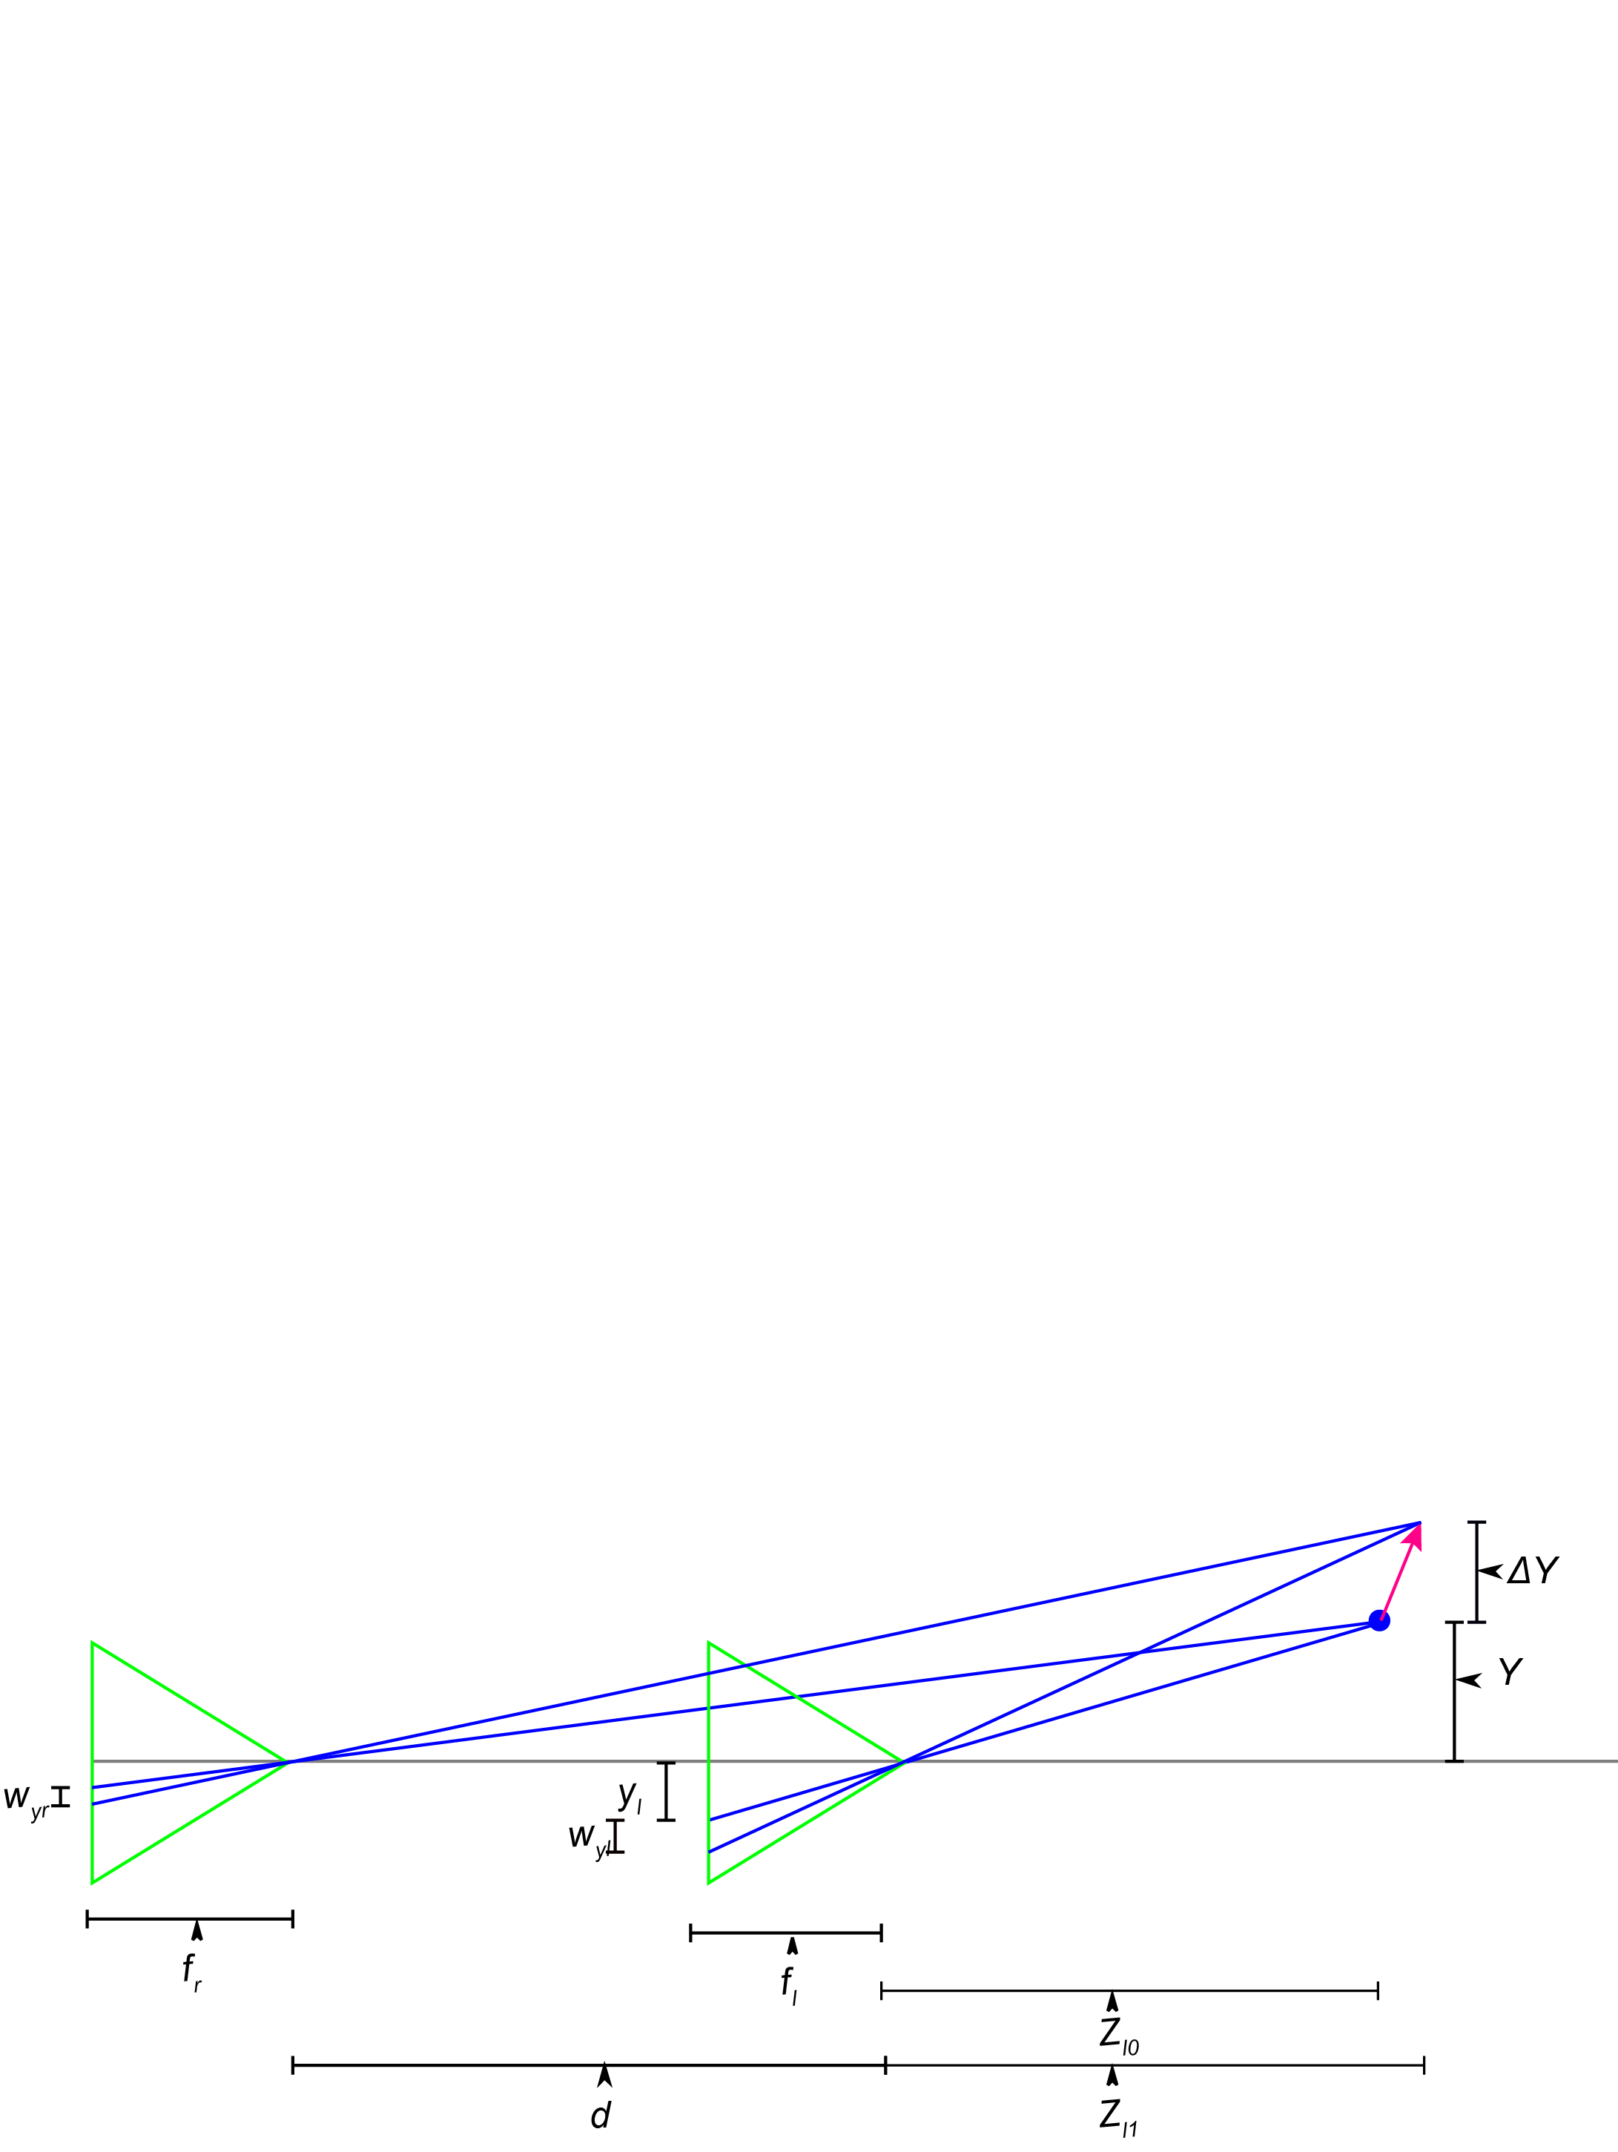

Fig. 3 Dual focal length binocular stereo camera rig geometry Y-Z view.

Now find the relationship between the optical flow, which does depend on $\dot{Z}$. Once again, we start with the projection equations and take the derivative with respect to time:

$\frac{dx}{dt}=w_{x}=-f\frac{d}{dt}\left(\frac{X}{Z}\right)$ (9)

$\frac{dy}{dt}=w_{y}=-f\frac{d}{dt}\left(\frac{Y}{Z}\right)$ (10)

$w_{x}=\frac{x\dot{Z}-f\dot{X}}{Z}$ (11)

$w_{y}=\frac{y\dot{Z}-f\dot{Y}}{Z}$ (12)

which can be written in homogeneous coordinates as:

$\overline{P}=\left[\begin{matrix}1 \\ 0 \\ 0\end{matrix} \begin{matrix}0 \\ 1 \\ 0\end{matrix} \begin{matrix}x/f \\ y/f \\ 0\end{matrix} \begin{matrix}0 \\ 0 \\ {-Z}/f\end{matrix}\right]$ (13)

$\overline{w}=\left[\begin{matrix}1 \\ 0 \\ 0\end{matrix} \begin{matrix}0 \\ 1 \\ 0\end{matrix} \begin{matrix}{-x}/f \\ {-y}/f \\ 0\end{matrix} \begin{matrix}0 \\ 0 \\ {-Z}/f\end{matrix}\right]\left[\begin{matrix}U \\ V \\ W \\ 1\end{matrix}\right]=\left[\begin{matrix}U-\frac{xW}{f} \\ V-\frac{yW}{f} \\ -\frac{Z}{f}\end{matrix}\right]=-\left[\begin{matrix}\frac{fU-xW}{Z} \\ \frac{fV-yW}{Z}\end{matrix}\right]$ (14)

In discrete form (11) becomes:

$w_{xl}=\frac{x_{l0}\dot{Z}-f_{l}\dot{X}}{Z_{l1}}$ (15)

$w_{xr}=\frac{x_{r0}\dot{Z}-f_{r}\dot{X}}{Z_{r1}}$ (16)

for the left and right cameras. Solving for the ratio of optical flow gives us:

$\frac{{\overline{w}}_{r}}{{\overline{w}}_{l}}=\overline{p}=\frac{Z_{l1}\left(x_{r0}\dot{Z}-f_{r}\dot{\overline{X}}\right)}{Z_{r1}\left(x_{l0}\dot{Z}-f_{l}\dot{\overline{X}}\right)}$ (17)

which gives:

$\overline{p}\left(x_{l}\right){\overline{w}}_{l}\left({\overline{x}}_{l}\right)={\overline{w}}_{r}\left({\overline{x}}_{l}+\overline{h}\left({\overline{x}}_{l}\right)\right)$ (18)

Which can be written as an energy functional:

$E_{match}=\int_{a}^{b}{\frac{1}{2}{\left[\overline{p}\left({\overline{x}}_{l}\right){\overline{w}}_{l}\left({\overline{x}}_{l}\right)-{\overline{w}}_{r}\left({\overline{x}}_{l}+\overline{h}\left({\overline{x}}_{l}\right)\right)\right]}^{2}dxdy}$ (19)

$E_{smooth_Z}=\frac{1}{2}\int_{a}^{b}{{\left\|∇Z_{l}\left({\overline{x}}_{l}\right)\right\|}^{2}dxdy}$ (20)

$E_{smooth_\dot{Z}}=\frac{1}{2}\int_{a}^{b}{{\left\|∇{\dot{Z}}_{l}\left({\overline{x}}_{l}\right)\right\|}^{2}dxdy}$ (21)

$E_{total}= {γE}_{match}+{\overline{α}E}_{smooth_Z}+\overline{β }E_{smooth_\dot{Z}}$ (22)

where

$\overline{α}={\left(α_{x},α_{y}\right)}^{T}$ (23)

$\overline{β}={\left(β_{x},β_{y}\right)}^{T}$ (24)

**Dual focal length stereo** As can be seen from the equation (7), in a binocular stereo rig where the cameras have different focal lengths, the traditional epipolar relationship between pixels in the reference image and pixels in the sensed image does not hold. While the disparity equations are more complex, this does not cause a problem for the numerical solution, but it permits matching constant flow regions which results from frontal planar surfaces in the scene. With a traditional binocular stereo camera rig, the flow in the reference and sensed image for a frontal planar region of the scene will be equal and any pixel will match any pixel. However, with a dual focal length binocular stereo rig, the ratio of the optical flow in the sensed and reference images will have a specific value depending on the distance to the scene. This permits correspondences to be found even in frontal planar regions of the scene that produce constant optical flow.

## 3.3 Coaxial Camera Rig

Referring to Figure 4, let ${\overline{x}}_{f}≔{(x_{f},y_{f})}^{T}$, ${\overline{x}}_{b}≔{(x_{b},y_{b})}^{T}$ represent points in the image domain of the front and back cameras. Let $\overline{h}(\overline{x})≔$ the disparity between ${\overline{x}}_{f}$ and ${\overline{x}}_{b}$ such that ${\overline{x}}_{f}$ and ${\overline{x}}_{b}-\overline{h}(\overline{x_{f}})$ represent the same point $\overline{X}\left({\overline{x}}_{f}\right)≔(X,Y)$ in the scene. Let $f_{f,}f_{b}≔$ the focal lengths for the front camera and back cameras and $Z({\overline{x}}_{f})≔$ the distance between the optical center of the front camera and a point in the scene corresponding to ${\overline{x}}_{f}$, the distance being measured along the optical axis. $b≔$ the distance between the optical center of the two cameras. ${\overline{w}}_{f},{\overline{w}}_{b}≔$ the projection of the 3D motion field onto the image planes of the front and back cameras respectively.

# Figure3

Fig. 4 Coaxial camera rig geometry.

As can be seen from Fig. 4, the coaxial camera has the same geometry in the X-Z plane as in the Y-Z plane, which in turn, is the same geometry as the stereo camera in the Y-Z plane, thus equation (7) derived above for the stereo camera Y-Z plane applies to the coaxial camera in both the X-Z and Y-Z planes:

$\overline{h}({\overline{x}}_{f})=\frac{{\overline{x}}_{f}\left(\frac{f_{b}}{f_{f}}Z-Z-b\right)}{Z+b}$ (25)

To determine the relationship between the optical flow in the front and back cameras we can rewrite equations (15) and (16) from the binocular stereo derivation as:

${\overline{w}}_{f}=\frac{{\overline{x}}_{f0}\dot{Z}-f_{f}\dot{\overline{X}}}{Z_{f1}}$ (26)

${\overline{w}}_{b}=\frac{{\overline{x}}_{b0}\dot{Z}-f_{b}\dot{\overline{X}}}{Z_{b1}}$ (27)

for the front and back cameras. Finding the ration between (26) and (27) gives:

$\frac{{\overline{w}}_{b}}{{\overline{w}}_{f}}=\overline{p}=\frac{Z_{f1}\left(x_{b0}\dot{Z}-f_{b}\dot{\overline{X}}\right)}{Z_{b1}\left(x_{f0}\dot{Z}-f_{f}\dot{\overline{X}}\right)}$ (28)

which gives:

$\overline{p}\left(x_{f}\right){\overline{w}}_{f}\left({\overline{x}}_{f}\right)={\overline{w}}_{b}\left({\overline{x}}_{f}+\overline{h}\left({\overline{x}}_{f}\right)\right)$ (29)

Which can be written as an energy functional:

$E_{match}=\int_{a}^{b}{\frac{1}{2}{\left[\overline{p}\left({\overline{x}}_{f}\right){\overline{w}}_{f}\left({\overline{x}}_{f}\right)-{\overline{w}}_{b}\left({\overline{x}}_{f}+\overline{h}\left({\overline{x}}_{f}\right)\right)\right]}^{2}dxdy}$ (30)

$E_{smooth_Z}=\frac{1}{2}\int_{a}^{b}{{\left\|∇Z_{f}\left({\overline{x}}_{f}\right)\right\|}^{2}dxdy}$ (31)

$E_{smooth_\dot{Z}}=\frac{1}{2}\int_{a}^{b}{{\left\|∇{\dot{Z}}_{f}\left({\overline{x}}_{f}\right)\right\|}^{2}dxdy}$ (32)

$E_{total}= {γE}_{match}+{\overline{α}E}_{smooth_Z}+\overline{β }E_{smooth_\dot{Z}}$ (33)

where

$\overline{α}={\left(α_{x},α_{y}\right)}^{T}$ (34)

$\overline{β}={\left(β_{x},β_{y}\right)}^{T}$ (35)

Due to the X-Z plane Y-Z plane symmetry of the coaxial camera rig, points along a radial line in the reference image will match points along a radial line in the sensed image.

Observation to work in with some plots:

1. The matching term matches both the flow in the x and y direction, which reduces the chance of a false positive match.
2. We are solving for Z and W directly, which allows sub-pixel disparity.
3. There is a 3D matching. As Z and W vary, the energy in x direction and y direction vary and in theory only one point matches. Need to try this along a line.

Here is an example on a frontal planar surface, which for optical flow is analogous to a featureless region in correspondences from features. We have motion in the X direction, no motion in the Y or Z direction. Looking at the optical flow in x, there is a Z estimate which gives a minimum energy for each value of W.

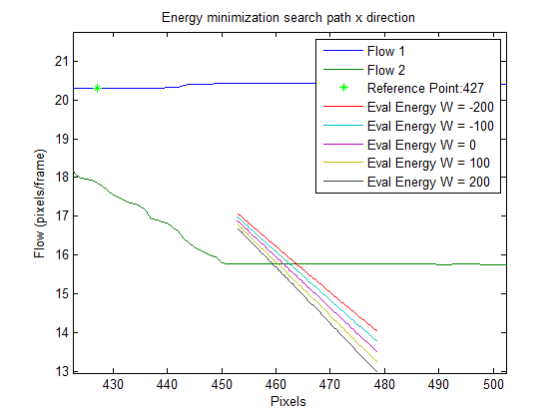

However, looking at the flow in the y direction (which is zero) there is only one value of Z which produces an energy minimum.

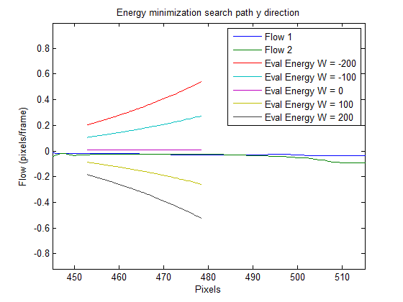

# 4 Numerical Solution

Equations 22 and 33 define global energies, which can be solved using a variety of algorithms including variational methods [19, 20], simulated annealing [3, 14, 30], cooperative methods [29, 33] and more recently graph-cut algorithms [6, 4, 17, 31, 33]. In our previous work [19, 20] we used a variational methods approach, which had some difficulties with initialization, with the stopping condition, was slow, and where $\dot{Z}$ lagged behind that for Z. In this paper we solve the energy minimization using the graph-cuts algorithm proposed by Boykov et. al [5, 4, 9, 21] and implemented by Veksler and Delong [36], which partitions the image pixels and labels into two sets along a surface (work on this partitioning idea).

Using Veksler and Delong's notation:

$E\left(L\right)= {E\left(L\right)}_{data}+{E\left(L\right)}_{smooth}+{E\left(L\right)}_{label}$ (8)

where

$L=\left\{\left(Z_{min},-W_{min}\right),\left(Z_{min}+1,-W_{min}\right), \left(Z_{min}+2,-W_{min}\right),…, \left(Z_{min},-W_{min}+1\right),\left(Z_{min}+1,-W_{min}+1\right), \left(Z_{min}+2,-W_{min}+1\right),…, \left(Z_{max},-W_{max}+1\right)\right\}$ (8)

is an arbitrary finite set of labels $L$

${E\left(L\right)}_{data}$ is the sum over all pixels $P$ in the reference image of the cost of assigning label $l$ to pixel $p$. Where $l$ is a specific (Z, W) combination and $p$ is a specific pixel location. Our matching term penalizes the difference between the optical flow in the reference image at pixel $p$ and the optical flow in the sensed image at $p+\overline{h}$ ($L)$. This is a two component penalty as both components of the optical flow contribute to the cost. This term is equivalent to our match term.

${E\left(L\right)}_{smooth}$ is the sum over all pairs of neighboring pixels $(p, q)$ in the reference image, where $(p, q)$ are 4-connected. This cost defines the pixel neighborhood structure and penalizes neighboring pixels that have different labels.

${E\left(L\right)}_{label}$ is the sum over all subsets of labels. This cost defines the label structure and penalizes non-adjacent Z and W values. This terms allows us to define the neighborhood structure of the labels where adjacent labels are not adjacent.

The combination of Esmooth and Elabel produce an 8-connected smoothness term similar to our Esmooth. 4 of the 8 connections are spatial, two encourage adjacent Z values and two encourage adjacent W values.

We use the expansion algorithm for energy minimization because 3 sets of labels

Our global energy has two main differences versus a traditional binocular stereo energy: 1) in matching optical flow, each pixel location in the reference frame has two values, one for the optical flow in the x direction and a second for the optical flow in the y direction and 2) instead of solving for disparity, we solve for W and Z directly and simultaneously.

We use the graph cuts algorithm developed by Boykov et. al. [4] that minimizes energies of the type of equations 7? and 8? for an arbitrary finite set of labels $L$ by partitioning the image pixels

As in [22], we define $P$ as the set of pixels in the left and right images. Put some kind of general definition for vertices and nodes/edges and how the energy relates to the edges. Make sure script V is defined. Also put some notes in about discrete increments for Z and W similar to stereo's discrete increments for disparity. $V$ is the set of pairs of pixels (one from the left image and one from the right image) that might correspond. Then:

$V=\left\{〈p,q〉|\overline{p}-\overline{q}∈L\right\}$ (8)

Where $L$ is the set of all possible combinations of Z and W: $L=\left\{\left(Z_{min},-W_{min}\right),\left(Z_{min}+1,-W_{min}\right), \left(Z_{min}+2,-W_{min}\right),…, \left(Z_{min},-W_{min}+1\right),\left(Z_{min}+1,-W_{min}+1\right), \left(Z_{min}+2,-W_{min}+1\right),…, \left(Z_{max},-W_{max}+1\right)\right\}$. Both Z and W can be in any units of measurement, which allows subpixel flow alignment. Similar to stereo graph-cuts implementations that assume that disparity falls within some limited range, we assume that Z and W fall within a limited range.

# 5 Results

## 5.1 Stereo Camera Rig

Our multimodal stereo camera rig consists of one camera with an RGB sensor and a second camera with an IR sensor. For the indoor scenes, the camera rig was mounted on a precision XY table and the camera rig was translated a known distance between frames. We used two measures of accuracy: 1) we measured the alignment of the flow fields and 2) we measured the accuracy of the 3D motion field reconstruction. This later measure is a combination of 3D reconstruction errors and optical flow computation errors.

For the indoor scenes, the camera rig was displaced 2 cm between images, equaivelent to a 30 FPS velocity of 0.6 m/S. Elements of the scene ranged from approximately 1m to 3m from the camera The cameras in the stereo rig had 4.8 micron (IR) and 6 micron (RGB) square pixels and 6.0 mm (IR) and 8 mm (RGB) focal lengths. The images were corrected for the difference in pixel size and focal length. The stereo baseline b = 76.2 mm and the difference in Z distance was d = 177.8. To compute optical flow, we used the large scale optical flow algorithm from Brox and Malik [7].

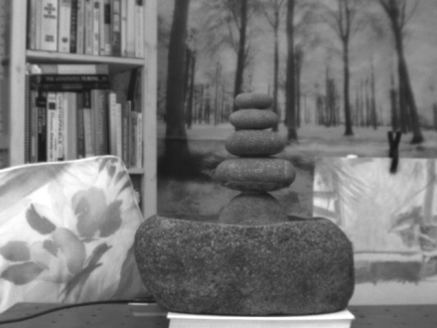 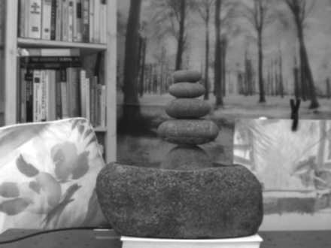

(a) (b) (c)

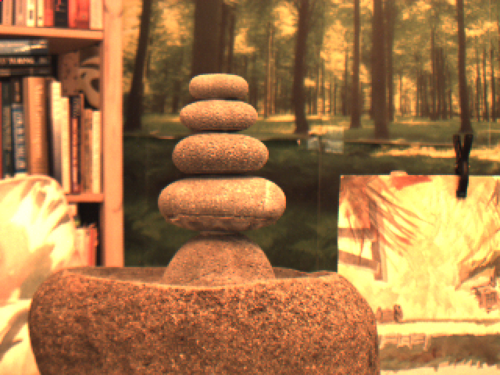 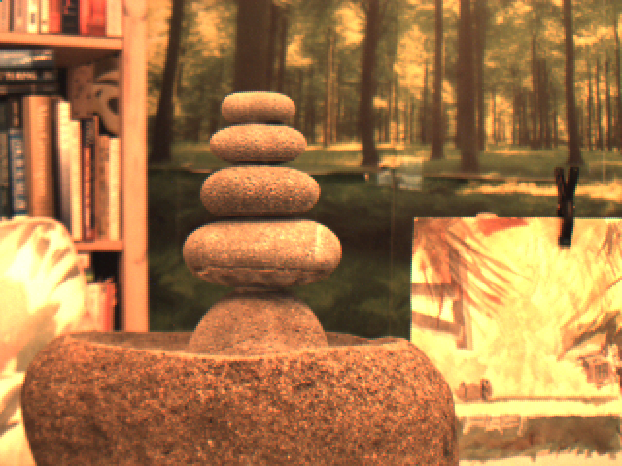 

(d) (e) (f)

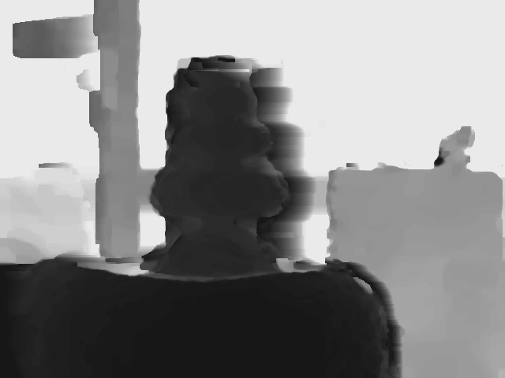

(g)

Fig. ?. Fountain image sequence, multi-modal stereo rig: (a) first IR image, (b) second IR image, (c) optical flow from IR image pair, (d) first RGB image, (e) second RGB image, (f) optical flow from RGB image pair, (g) resulting depth map.

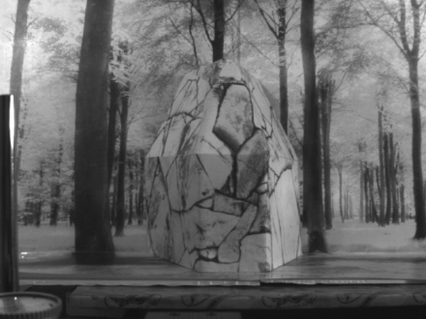 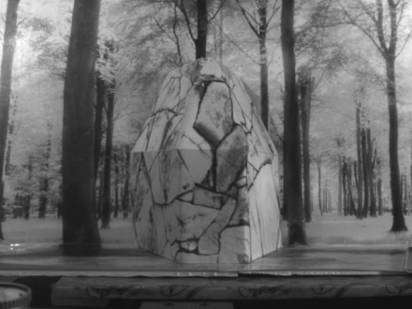 

(a) (b) (c)

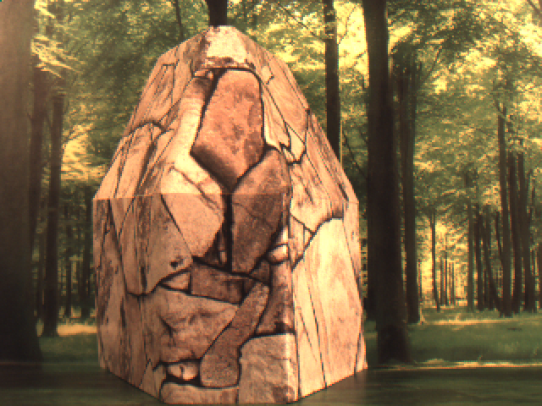 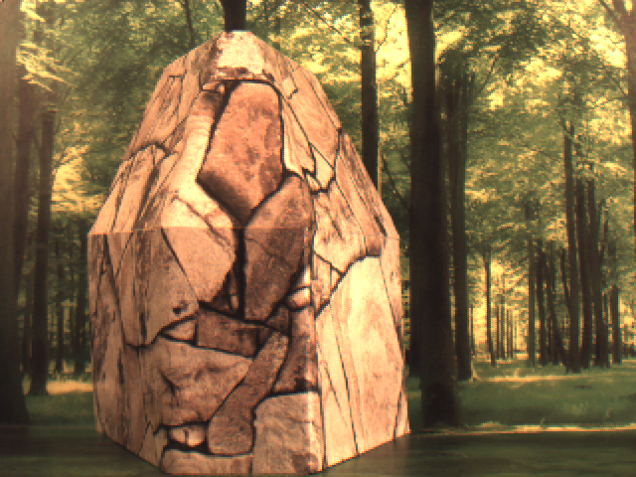 

(d) (e) (f)

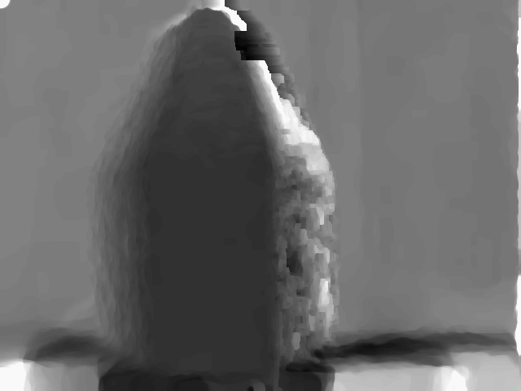

(g)

Fig. ?. Flagstone image sequence, multi-modal stereo rig: (a) first IR image, (b) second IR image, (c) optical flow from IR image pair, (d) first RGB image, (e) second RGB image, (f) optical flow from RGB image pair, (g) resulting depth map.

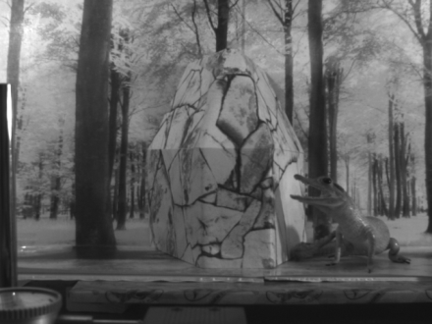 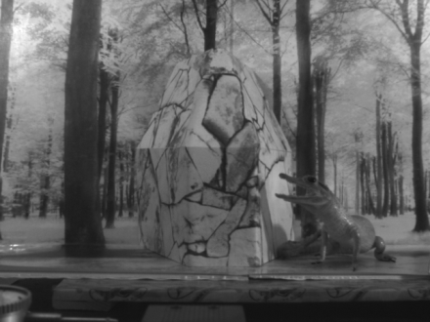 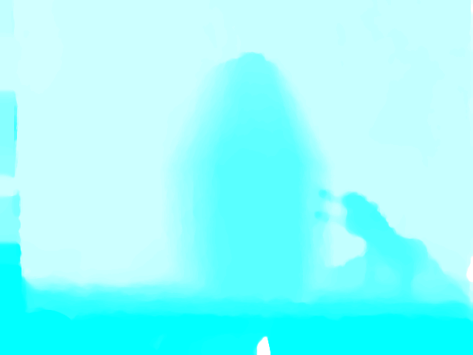

(a) (b) (c)

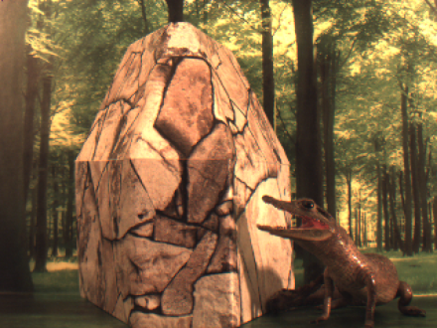 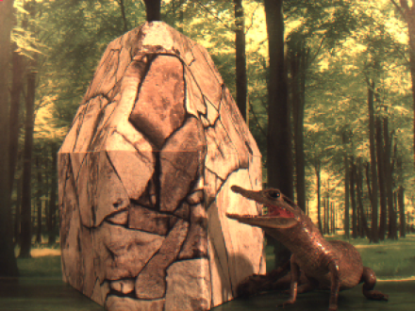 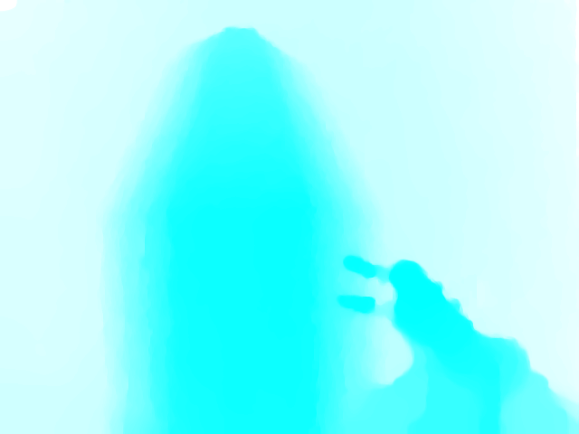

(d) (e) (f)

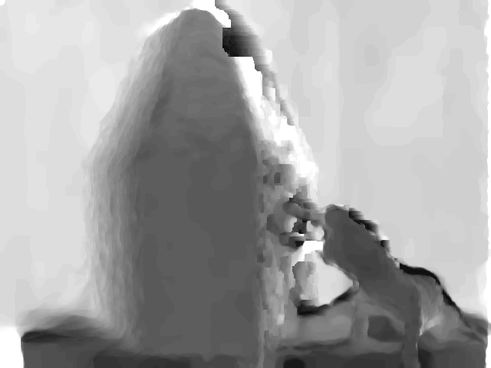

(g)

Fig. ?. Flagstone with alligator image sequence, multi-modal stereo rig: (a) first IR image, (b) second IR image, (c) optical flow from IR image pair, (d) first RGB image, (e) second RGB image, (f) optical flow from RGB image pair, (g) resulting depth map.

## 5.2 Coaxial Camera Rig

The coaxial camera rig consists of a pair of cameras with RGB sensors on the same XY table described above. The camera arrangement is shown in Figure 14. Coaxial camera depth accuracy was also determined by estimating the camera movement using the estimated depth map and optical flow field and comparing the estimated camera rig displacement to the actual displacement.

Our scene (Figure 15) consisted of a 10 cm diameter by 17 cm tall cylinder located 75 cm from the optical center of the front camera in the camera rig and a planar background located 115 cm from the optical center of the front camera. There is a relatively large discontinuity between the cylinder and the planar background similar in scale to that of our second set of synthetic experiments. Velocity in the XY plane was 0.3 m/s, which when scaled to match our synthetic images would be 4 m/s. The cameras in the coaxial rig have 0.006 mm square pixels, focal lengths of 7.7 mm and 5.8 mm (front and back respectively), and b = 143.3 mm. We set $γ= 2∙{10}^{6}$ and $α= .05$. As with the stereo rig, we used the large scale optical flow algorithm from Brox and Malik.

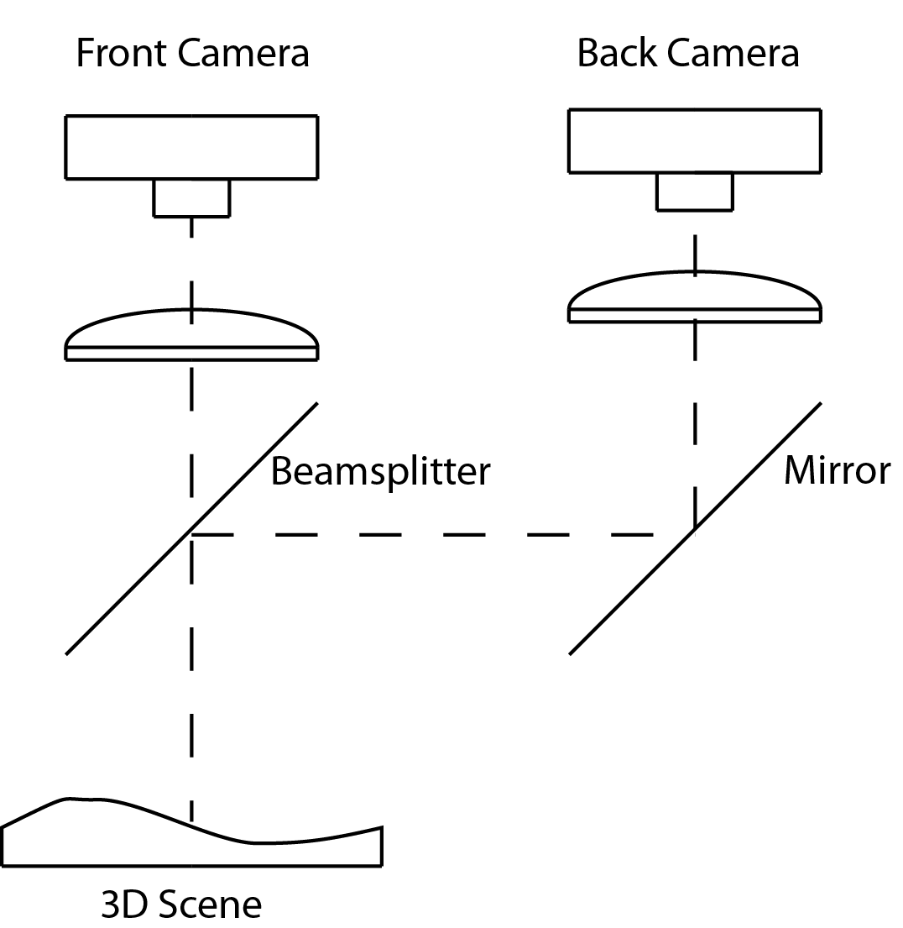

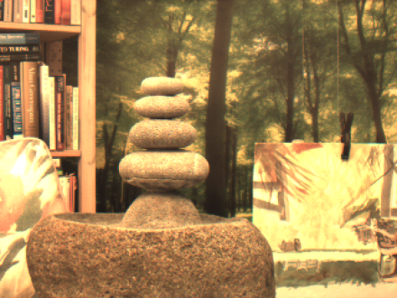 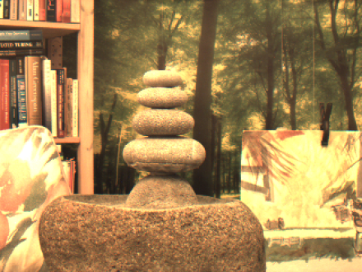 

(a) (b) (c)

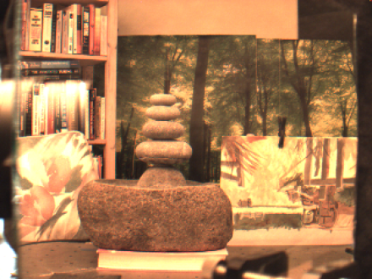 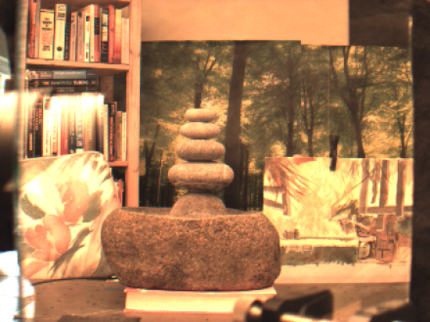 

(d) (e) (f)

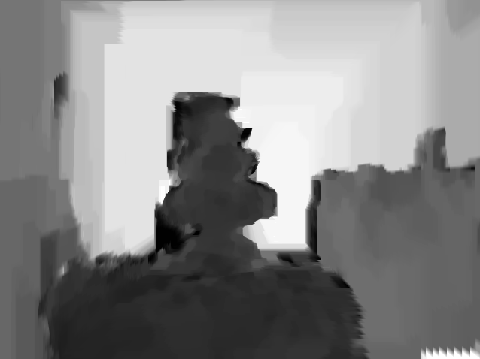

(g)

Fig. ?. Fountain image sequence, coaxial camera rig: (a) first front camera image, (b) second front camera image, (c) optical flow from front camera image pair, (d) first back camera image, (e) second back camera image, (f) optical flow from back camera image pair, (g) resulting depth map.

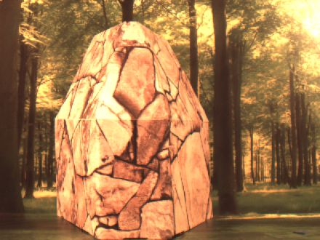 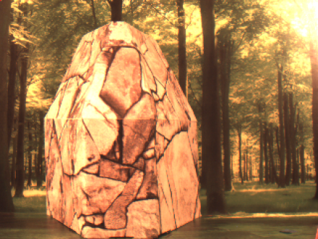 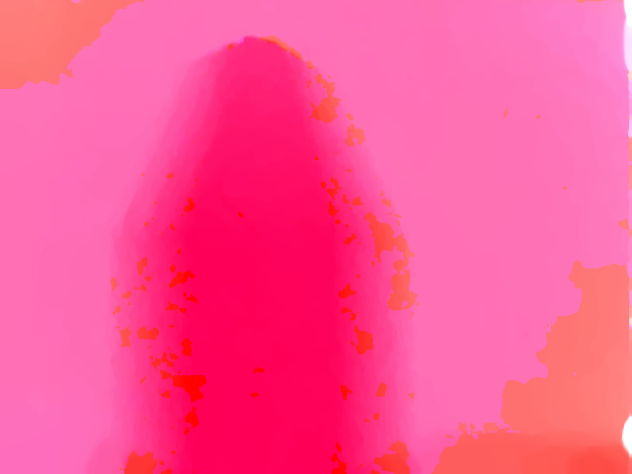

(a) (b) (c)

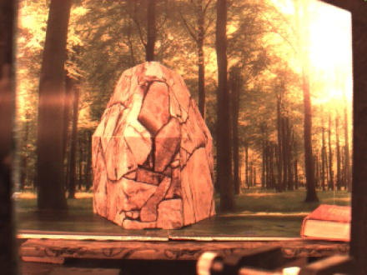 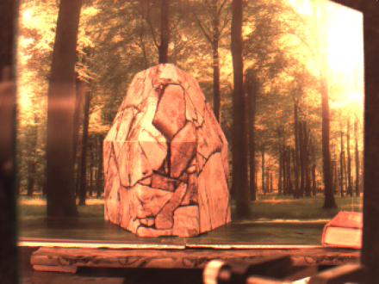 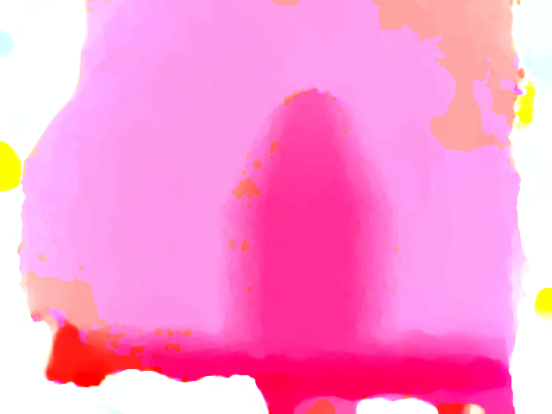

(d) (e) (f)

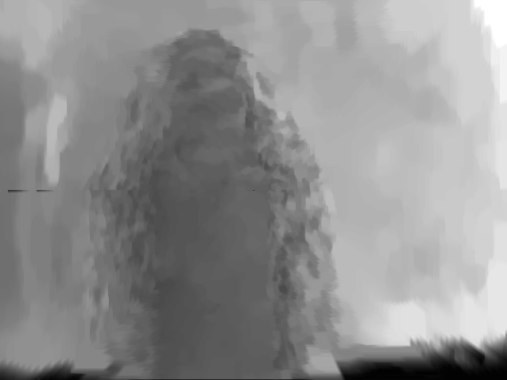

(g)

Fig. ?. Flagstone image sequence, coaxial camera rig: (a) first front camera image, (b) second front camera image, (c) optical flow from front camera image pair, (d) first back camera image, (e) second back camera image, (f) optical flow from back camera image pair, (g) resulting depth map.

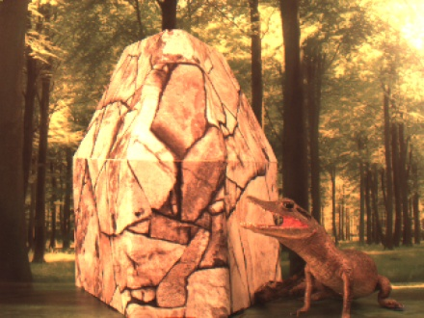 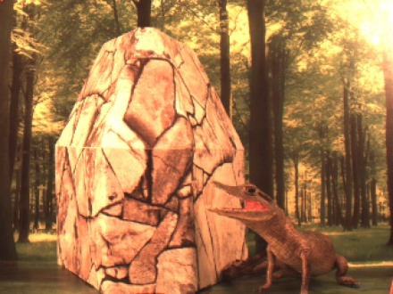 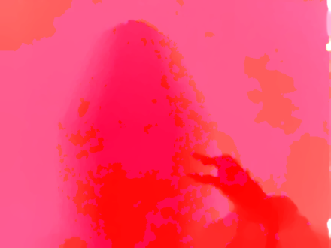

(a) (b) (c)

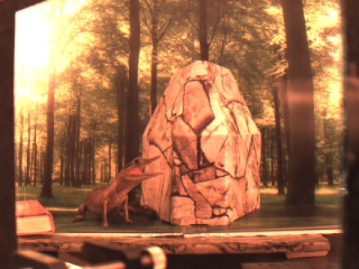 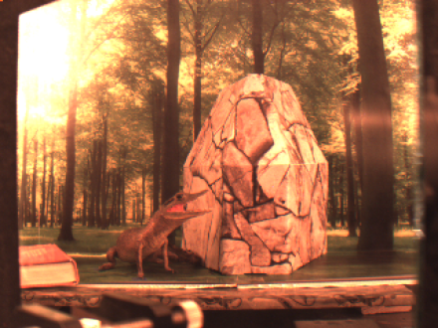 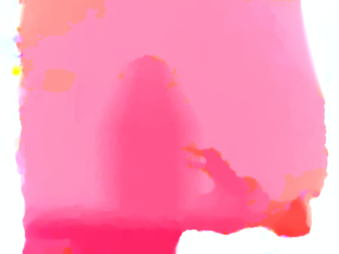

(d) (e) (f)

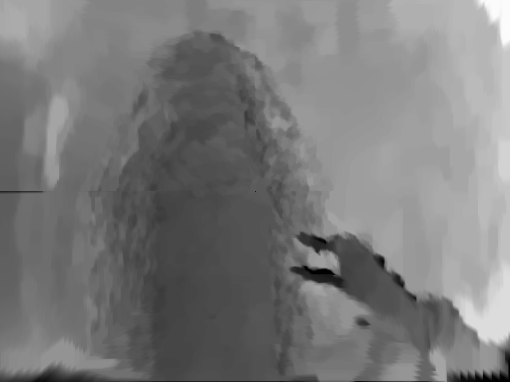

(g)

Fig. ?. Flagstone with alligator image sequence, coaxial camera rig: (a) first front camera image, (b) second front camera image, (c) optical flow from front camera image pair, (d) first back camera image, (e) second back camera image, (f) optical flow from back camera image pair, (g) resulting depth map.

# 6 Conclusions

Our results provide solid evidence that it's possible to find image correspondence using the optical flow fields provided that there is sufficient motion between the camera and the scene and that the scene has sufficient texture to produce optical flow. One advantage of our method is that images that don't have common pixel intensities or features can be aligned. Another advantage is that highly accurate sub-pixel alignment is possible in the center region of a coaxial camera. Both cases permit the estimation of dense disparity maps which can be converted into dense depth maps for 3D reconstruction and the relative velocity estimation between the scene and the camera rig.

With sufficient motion between the cameras and the scene and a scene that produces sufficient optical flow, our technique produces image alignment for a multimodal camera rig which is comparable to feature and pixel intensity based methods that align pairs of visible light images.

Our technique appears to be robust to flow fields that are not a good representation of the motion field as long as the flow fields in the two cameras reflect the same errors (e.g. the aperture problem and variation in illumination). This suggests that the intra-camera images might be used as an additional term in the optical flow computation (e.g. intra-camera image smoothing) to improve both the optical flow computation and the results intra-camera image alignment.

Our results suggest that our technique could produce good results on moving multimodal camera rig (scanning security camera or vehicle mounted camera) and for a coaxial camera rig, allow stereo reconstruction in situations where a standard stereo baseline isn't feasible (e.g. endoscope or bore-scope).

# Appendix A: Full Derivations?

## References

Author Biographies and Photographs

**Richard Kirby** received his BS degree in Mechanical Engineering from the University of California Santa Barbara in 1981 and his MBA from the University of Oregon in 1984. He is currently a PhD candidate at the University of Utah in the School of Computing. His particular interest is in using computer vision to measure displacement and velocity of deformable 3D objects, particular elite athletes. In partnership with the US Olympic Ski Team he developed an optical flow based training device for Olympic skiers which provides real-time audible technique feedback to skiers while training. He holds twelve patents related to using optical flow for measuring motion. In addition to his work with the US Olympic Ski team Richard has consulted for the French Olympic Ski team, the Swedish Olympic Committee, Rossignol, Salomon, Atomic, Swix, the Seattle Seahawks, and Red Bull High Performance (sports science) related to measuring athlete performance. He is a member of SPIE.

**Ross Whitaker** earned a B.S. degree in Electrical Engineering and Computer Science from Princeton University in 1986, and a Ph.D. in Computer Science from the University of North Carolina in 1994. Since 2000 he has been at the University of Utah, where he is the Director of the School of Computing and a Professor in the Scientific Computing and Imaging Institute. He is a recipient of the NSF Career Award and an IEEE Fellow. He teaches discrete math, scientific visualization, and image processing. He has leads a graduate-level research group in image analysis, geometry processing, and scientific computing, with a variety of projects supported by both federal agencies and industrial contracts.

**Caption List**

## References

[1] N. Asada, m. Baba, and A. Oda, "Depth from Blur by Zooming," in *Proceedings of the Vision Interface Annual Conference*, Ottawa, Canada, 2001.

[2] M. Baba, N. Asada, and T. Migita, "A Thin Lens Based Camera Model for Depth Estimation from Defocus and Translation by zooming," in *Proc. 15th International Conference on Vision Interface*, Calgary, Canada, 2002.

[3] S. T. Barnard, "Stochastic stereo matching over scale," *IJCV,* vol. 3(1):17-32, 1989.

[4] Y. Boykov, O. Veksler, and R. Zabih, "Fast approximate energy minimization via graph cuts," in *IEEE Transactions on Pattern Analysis and Machine Intelligence*, 1998.

[5] Y. Boykov and V. Kolmogorov, "An Experimental Comparison of Min-Cut/Max-Flow Algorithms for Energy Minimization in Vision," in *IEEE TPAMI*, 2004.

[6] Y. Boykov and V. Kolmogorov, "Graph Cuts in Vision and graphics theories and Applications," *IEEE Trans. Pattern Analysis and Machine Intelligence,* vol. Vol. 26, No. 9, September, 2004.

[7] T. Brox and J. Malik, "Large Displacement Optical Flow Desriptor Matching in Variational Motion Estimation," *IEEE Transactions on Pattern Analysis and Machine Intelligence,* 2010.

[8] F. B. Campo, R. L. Ruiz, and A. D. Sappa, "Multimodal Stereo Vision System: 3D Data Extraction and Algorithm Evaluation," *IEEE Journal of Selected Topics In Signal Processing, vol. 6, no.5,* 2012.

[9] A. Delong and H. Osokin, "Fast Approximate Energy Minimization with Label Costs," in *CVPR*, 2010.

[10] G. Egnal, "Mutual information as a Stereo Correspondence Measure," *Technical Report MS-CIS-00-20, Computer and Information Science, University of Pennsylvania, Philadelphia, USA,* 2000.

[11] C. Fookes, A. Lamanna, and M. Bennamoun, "A new stereo image matching technique using mutual information," in *In Proceedings of the International Conference on Computer, Graphics and Imaging, CGIM'01, pages 168-173, Honolulu, USA, 2001. Iasted, ISBN 0-88986-303-2.*, 2001.

[12] C. Fookes, S. Maeder, S. Sridharan, and J. Cook, "Multi-Spectral Stereo Image Matching using Mutual Information," in *Proceedings of the 2nd International Symposium on 3D Data Processing, Visualization, and Transmission*, 2004.

[13] H. Gao, J. Liu, Y. Yu, and Y. Li, "Distance measurement of zooming image for a mobile robot," *International Journal of Control, Automation and Systems,* vol. 11, pp. 782-789, 2013.

[14] S. Geman and D. Geman, "Stochastic relaxation, Gibbs distribution, and the Bayesian restoration of images.," *IEEE TPAMI,* vol. 6(6):721-741, 1984.

[15] A. A. Goshtasby, *Image registration principles tools methods*: Springer, 2012.

[16] R. Hartly and A. Zisserman, *Multiple View Geometry in computer vision*: Cambridge University Press, 2003.

[17] P.-J. Kack, "Robust Stereo Correspondence Using Graph cuts," PhD, KTH Numerical Analysis and Computer Sciences, 2004.

[18] R. Kirby, "Three Dimensional Surface Mapping System Using Optical Flow US2013321790A1," USA Patent, 2012.

[19] R. kirby and R. Whitaker, "3D reconstruction from images taken with a coaxial camera rig " in *SPIE Optics + Photonics*, San Diego, 2016.

[20] R. Kirby and R. Whitaker, "A novel automated method for doing revistration and 3D reconstruction from multi-modal RGB/IR image sequences," in *SPIE Optics + Photonics*, San Diego, 2016.

[21] V. Kolmogorov and R. Zabih, "What Energy Functions can be Minimized via Graph Cuts?," in *IEEE TPAMI*, 2004.

[22] V. Kolmogorov and R. Zabih, *Graph cut algorithms for binocular stereo with occlusions*: Springer, 2006.

[23] S. Krotosky and T. Mohan, "Registration of Multimodal Stereo Images using Disparity Voting from Correspondence Windows," in *IEEE Conf. on Advanced Video and Signal based Surveillance (AVSS’06)*, 2006.

[24] S. Krotosky and M. Trivedi, "Multimodal Stereo Image Registration for Pedestrian Detection," in *in Proc. IEEE Intell. Transp. Syst. Conf., Sep. 2006, pp. 109–114*, 2006.

[25] S. Krotosky and M. Trivedi, "Mutual information based registration of multimodal stereo videos for person tracking," *Computer Vision and Image Understanding,* vol. 106, pp. 270-287, 2007.

[26] J. Lavest, G. Rives, and M. Dhome, "Three Dimensional Reconstruction by Zooming," *IEEE Transactions on Robotics and Automation,* vol. 9, pp. 196-207, 1993.

[27] J. Lavest, G. Reves, and M. Dhome, "Modeling an Object of Revolution by Zooming," *IEEE Transactions on Robotics and Automation,* vol. VOL. II, NO. 2, April 1995, 1995.

[28] J. Ma and S. I. Olsen, "Depth from Zooming," *J. Opt. Soc. Am. A* vol. 7, October 1990 1990.

[29] D. Marr and T. Poggio, "Cooperative computation of stereo disparity," *Science* vol. 194, 283-287, 1976.

[30] J. Marroquin, S. Mitter, and T. Poggio, "Probabilistic solution of ill-posed problems in computational vision," *J. Am. Stat. Assoc.,* vol. 82(397):76-89, 1987.

[31] S. Roy and I. Cox, "A maximum-flow formulation of the N-camera stereo correspondence problem," *ICCV,* vol. pp. 492-499, 1998.

[32] D. Scharstein and R. Szeliski, "A taxonomy and evaluation of dense two frame stereo correspondance agorithms," in *IJCV*, 2001.

[33] D. Scharstein, R. Szeliski, and R. Zabih, "A taxonomy and evaluation of dense two frame stereo correspondence algorithms," *International Journal of Computer Vision* vol. 47, pp. 7-42, 2002.

[34] R. Szeliski, *Computer Vision. Algorithms and Applications*. New York: Springer, 2011.

[35] A. Toraby and G. Bilodeau, "Local self-similarity as a dense stereo correspondence measure for themal visible video registration," *Computer Vision and Pattern Recognition Workshops (CVPRW), 2011 IEEE Computer Society Conference on,* pp. 61 - 67, 2011.

[36] O. Veksler and A. Delong. (2007). *GCoptimization*. Available: http://www.csd.uwo.ca/faculty/olga/software.html

[37] A. Verri and T. Poggio, "Motion Field and Optical Flow: Qualitative Properties," *IEEE Trans. Pattern Analysis and Machine Intelligence, 11(5), pp. 490-498, May,* 1989.

[38] P. Viola and W. M. Wells, "Alignment by Maximization of Mutual Information," *Intl. J. of Computer Vision, vol. 24, no. 2, pp. 137–154,,* 1997.

[39] M. Yaman and S. Kalkan, "An iterative adaptive multi-modal stereo-vision method using mutual information," *Journal of Visual Communication and Image Representation,* vol. 26, pp. 115-131, 2015.

[40] Y. Zhang and K. Qi, "Snake-Search Algorithm for Stereo Vision Reconstruction via Monocular System," presented at the The 5th Annual IEEE Conference on Cyber Technology in Automation, and Control, Intelligent Systems, Shenyang, China, 2015.

[41] B. Zitová and J. Flusser, "Image registration methods: a survey," *Image and Vision Computing,* vol. 21, pp. 977-1000, 2003.